**Transmission of student data files via WebSAMS**

1. **Procedures**
2. Goes to CDS 🡪 Incoming Message
   * Decrypt the parameter file, “TSA parameter file for secondary school”
3. Goes to HKEAA 🡪 TSA 🡪 Data Communication 🡪 Process Incoming Data
   * Import parameter file, “TSA parameter file for secondary school”
4. Goes to HKEAA 🡪 TSA 🡪 Maintain Student Data
   * Maintain the student data and save
5. Goes to HKEAA 🡪 TSA 🡪 Data Communication 🡪 Prepare Outgoing Data
   * Prepare the TSA Student Data file and check the report. If there is no problem, confirm the TSA Student Data file.
6. Goes to CDS 🡪 Outgoing Message 🡪 Maintain Message
   * Encrypt and send the TSA Student Data file
7. 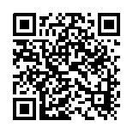**References**
8. Powerpoint on submission of TSA student data for Secondary Schools in WebSAMS

(<http://www.edb.gov.hk> 🡪 [School Administration and Management > Administration > IT Systems for Schools > WebSAMS > Briefing Sessions & Workshops](http://www.edb.gov.hk/tc/sch-admin/admin/sch-it-systems/websams/seminar.html))

1. 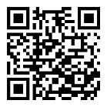Frequent Asked Questions

(<http://cdr.websams.edb.gov.hk> 🡪 [參考資料 > 常見問題及答案 >](http://cdr.websams.edb.gov.hk/html/Q&A/hke.html)

[香港考評局程序 > 全港性系統評估](http://cdr.websams.edb.gov.hk/html/Q&A/hke.html))

1. 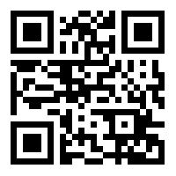**Enquiries**
2. WebSAMS School Liaison Officers

(<http://cdr.websams.edb.gov.hk> 🡪 主頁 🡪 常用電話/電郵/地址 >

網上校管系統學校聯絡主任名單及聯絡方法)

1. WebSAMS Helpdesk

Telephone number: 3125 8510

Fax number: 3125 8999

Email: websams_support@hk.ncs-i.com

1. CDS Helpdesk

Telephone number: 3464 0550

Fax number: 3464 0568

Email:  cdshelpdesk@edb.gov.hk